What type of DBMS exists?
Most DBMS are grouped by the data model they use (relational, key–value, document, column-family, graph, object-oriented), and each model is better suited to certain kinds of data and queries. Relational DBMS work best for structured, transactional business data, while NoSQL systems (key–value, document, column-family, graph) trade some relational features for more flexibility and horizontal scalability.
How DBMS / databases are classified
A “database type” usually means the logical data model (tables, documents, key–value, etc.), but databases are also classified by workload (OLTP vs OLAP), storage format (row vs columnar), and architecture (centralized vs distributed, cloud, embedded). One concrete DBMS product can belong to several categories at the same time (for example, a relational, columnar, analytical, distributed, cloud-managed database).
By default when we talk about “types of DBMS” we usually mean these classic data-model families: hierarchical, network, relational, and object-oriented. Modern practice adds NoSQL models (key–value, document, column-family, graph) as additional DBMS types.

Main DBMS types by data model

Relational DBMS (RDBMS)
- Model: Data in tables (relations) with rows and columns, fixed schema, and defined relationships via primary/foreign keys.
- Key features: SQL, joins across tables, constraints, ACID transactions, strong consistency.
- Best suited for: Highly structured data where relationships are well known and stable, and correctness of transactions is critical (finance, ERP, CRM, inventory, reservations, etc.).
- Examples: PostgreSQL, MySQL, Oracle, SQL Server, Exasol.

Key–value DBMS (NoSQL)
- Model: Simple map from key → value; the DBMS treats the value as opaque data.
- Key features: Very fast reads/writes by key, minimal or no schema, no joins, often in-memory or log-structured for speed.
- Best suited for: Caching, session storage, feature flags, simple user state where you always access by key and need low latency.
- Examples: Redis, Amazon DynamoDB in key–value mode, Memcached.

Document DBMS (NoSQL)
- Model: Stores JSON-like or BSON/XML documents with nested fields; documents in the same collection can have different structures.
- Key features: Flexible schema, nested attributes, indexes on document fields, rich queries over documents.
- Best suited for: Semi-structured data where records vary (content management, product catalogs, user profiles, API backends).
- Examples: MongoDB, CouchDB, Firebase Firestore.

Column-family / wide-column DBMS (NoSQL)
- Model: Rows identified by a row key, with columns grouped into column families; different rows can have different columns.
- Key features: Designed for horizontal scale, sparse data, and large distributed read/write workloads; schema-light.
- Best suited for: Time-series and event data, logs, telemetry, large write-heavy systems and real-time analytics over big data.
- Examples: Apache Cassandra, HBase, Google Bigtable.

Graph DBMS (NoSQL, but often treated separately)
- Model: Nodes (entities) and edges (relationships), often with properties on both.
- Key features: Relationship-first model, efficient graph traversals, pattern matching (e.g. “friends of friends”), flexible schemas.
- Best suited for: Highly connected data where relationships are the main focus: social graphs, recommendations, fraud detection, network analysis.
- Examples: Neo4j, JanusGraph, Amazon Neptune.

Object-oriented DBMS (OODBMS)
- Model: Stores objects directly, similar to classes and objects in OOP languages (including attributes and sometimes methods).
- Key features: Object persistence without ORM, class hierarchies, encapsulation of behavior with data.
- Best suited for: Specialized engineering and simulation systems, or applications tightly coupled to an OOP language where impedance mismatch with SQL is a problem.
- Examples: ObjectDB, db4o.

Older models: hierarchical and network DBMS
- Hierarchical DBMS: Tree structure with parent–child records (each child has exactly one parent).
  - Suited for naturally hierarchical data such as file systems or some directory/banking systems; largely historical but still used in some legacy software like IBM IMS.
- Network DBMS: Graph-like structure allowing records to have multiple parents, modeling many-to-many relationships directly.
  - Used historically in telecom, supply chains, and other complex relationship data before relational and modern graph DBMS became dominant.

Other useful classification axes (short)
Even with the same data model (e.g. relational), DBMS differ by workload and architecture.
- By workload:
  - OLTP: Short, frequent, write-heavy transactions (orders, bank transfers, account updates).
  - OLAP / analytical: Large, read-heavy queries, aggregations over many rows/columns for BI and reporting; often columnar and distributed.
- By storage format: Row-oriented (good for OLTP point lookups) vs columnar (good for analytic scans and aggregations).
- By architecture: Centralized vs distributed, embedded vs cloud-managed.

Relational vs NoSQL: big picture
Relational and NoSQL databases mainly differ in data model, schema flexibility, query language, consistency guarantees, and scaling strategy.

High-level comparison
Aspect | Relational DBMS | NoSQL DBMS (general)
Data model | Tables, rows, columns; fixed schema. | Non-tabular: key–value, document, column-family, graph, etc.
Schema | Predefined, strongly enforced; schema changes are controlled. | Often flexible or schema-optional; records can vary in structure.
Query language | SQL, joins, aggregations, rich declarative queries. | Varies: some use SQL-like queries, others use APIs or model-specific languages.
Consistency & transactions | Strong ACID transactions by default, strong consistency typical. | Many favor eventual consistency and relaxed transactions to scale; some newer systems add stronger guarantees.
Scaling | Traditionally scale-up (bigger single server), with sharding/replication as advanced options. | Designed for horizontal scale-out across many nodes from the beginning.
Best suited for | Structured business data, complex joins, strong correctness (banking, ERP, classic web backends). | Big data, semi-structured data, high-throughput web/mobile apps, or relationship-heavy workloads, depending on the NoSQL subtype.

Relational vs each major NoSQL type

Relational vs key–value
- Relational:
  - Stores rich structured records split across multiple tables; supports complex joins and ad-hoc queries in SQL.
  - Good when you need to combine data in many ways (e.g. reporting across customers, orders, products) and keep strong transactional guarantees.
- Key–value:
  - Only supports direct access by key; no joins or rich predicates, though some products add limited secondary indexing.
  - Excellent as a cache/session store in front of a relational DB, where you just need “get/set this object by ID” at very high speed.
You usually don’t replace an RDBMS with a key–value store for core business data; you use them together (RDBMS for system of record, key–value for fast lookups).

Relational vs document
- Relational:
  - Requires you to break entities into normalized tables, which is great for integrity but sometimes awkward for highly nested or frequently changing structures.
- Document:
  - Let you store the whole object (e.g. a user profile with nested addresses, preferences, settings) in one document, with flexible fields.
  - Better when records are semi-structured and evolve often, and when you mostly need to retrieve whole documents or filter on a few fields rather than do complex joins.
In practice, many systems use a relational database for core transactional data and a document DB for flexible content or user-generated data.

Relational vs column-family / wide-column
- Relational:
  - Typically row-oriented and optimized for OLTP queries touching a few rows at a time.
- Column-family:
  - Optimized for huge, distributed datasets and write-heavy workloads, with rows that can have many sparse columns and are partitioned across a cluster.
  - Very good for time-series, logs, and IoT data where you know the main access patterns ahead of time and design the row keys and column families accordingly.
Here, the trade-off is: relational gives you flexibility in ad-hoc queries and transactions; column-family gives you performance and scale for pre-planned access patterns.

Relational vs graph
- Relational:
  - Can model relationships using foreign keys, but multi-hop traversals (e.g. “friends of friends of friends”) require multiple joins and become expensive at scale.
- Graph:
  - Relationships are first-class; traversing many hops (paths) is fast and natural.
  - Ideal when queries center on connectivity and patterns (“find potential fraud rings”, “recommend users with similar neighborhoods in the graph”).
You might still keep transactional data in a relational DB and export selected entities/relationships into a graph DB specifically for recommendation or fraud-detection algorithms.

How to choose the right type :
A simple checklist is:
- Schema stability:
  - Stable, well-known schema → relational DBMS.
  - Evolving or heterogeneous records → document or key–value.
- Query style:
  - Many joins, complex analytics → relational (possibly columnar/OLAP engine).
  - Simple key lookups → key–value.
  - Deep relationship queries → graph.
- Workload pattern:
  - Short, frequent transactions → OLTP-oriented relational system.
  - Long-running aggregates over big data → OLAP / analytical database (often columnar, sometimes still relational by model).
- Scalability needs:
  - Single server or moderate scale → traditional RDBMS is usually enough.
  - Massive scale and global distribution → distributed NoSQL (key–value, column-family, some document DBs) or distributed SQL/NewSQL.
Web Application Frameworks
- A web application framework is a software framework that standardizes and simplifies building web apps, services, and resources.
- Server-side frameworks (Django, Express, Rails, ASP.NET, Laravel, etc.) help you write and maintain the code that runs on the server: routing, database access, authentication, and generating responses.
- Client-side frameworks (React, Angular, Vue, etc.) are JavaScript frameworks that run in the browser and execute application logic on the client, focusing on interactive user interfaces and SPA behavior.
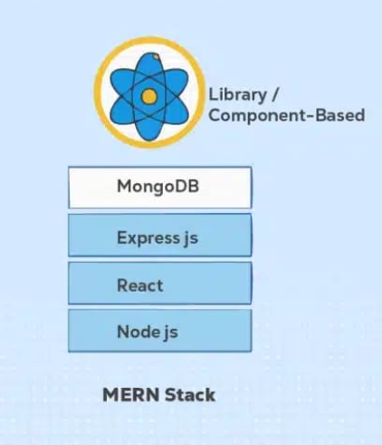

JAVASCRIPT cheat sheet:

Basics
JavaScript is a dynamically typed, prototype-based language used mainly in browsers and also on servers (Node.js). To practice JavaScript, all you have to do is press F12 and use the browser console !
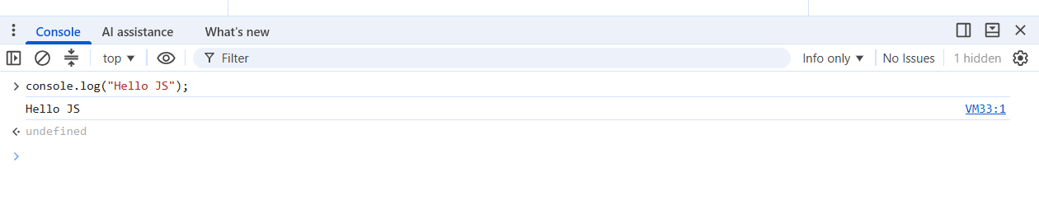
js
// Single-line comment
/*
Multi-line comment
*/

// Console
console.log("Hello JS");

Variables
Use let for reassignable variables, const for values you don’t reassign, and avoid var in modern code.
js
let count = 0; // block-scoped, can change
const PI = 3.14; // block-scoped, cannot be reassigned
// var oldStyle = 10; // function-scoped

Data types
Primitive types: string, number, boolean, null, undefined, bigint, symbol.
js
let name = "Ali"; // string
let age = 25; // number
let happy = true; // boolean
let empty = null; // null
let nope; // undefined
let big = 123n; // bigint
let sym = Symbol("id");// symbol
Check type:
js
typeof name; // "string"
typeof age; // "number"

Operators
Arithmetic, comparison, logical, and assignment operators work as follows.
js
// Arithmetic
a + b; a - b; a * b; a / b;
a % b; // remainder
a ** b; // exponent

// Comparison (return true/false)
a === b; // strict equality (no type coercion)
a !== b;
a > b; a < b; a >= b; a <= b;

// Logical
cond1 && cond2;
cond1 || cond2;
!cond1;

// Assignment
x = 1;
x += 2; // x = x + 2
x *= 3;

Control flow
Use if, else if, else, switch, and loops (for, while, for...of).
js
if (age >= 18) {
console.log("Adult");
} else {
console.log("Minor");
}

switch (color) {
case "red":
console.log("Stop");
break;
case "green":
console.log("Go");
break;
default:
console.log("Unknown");
}

// Loops
for (let i = 0; i < 3; i++) {
console.log(i);
}

let i = 0;
while (i < 3) {
console.log(i);
i++;
}

Functions
Functions can be declared, expressed, or written as arrow functions.
js
// Function declaration (hoisted)
function add(a, b) {
return a + b;
}

// Function expression
const multiply = function (a, b) {
return a * b;
};

// Arrow function
const square = (x) => x * x;

// Default parameters
function greet(name = "World") {
console.log("Hello " + name);
}

Arrays
Arrays are ordered lists; they have many useful methods like push, map, filter, forEach.
js
const nums = [1, 2, 3];

// Access & update
nums[0]; // 1
nums[1] = 5;

// Basic methods
nums.push(4); // [1,2,3,4]
nums.pop(); // removes last

// Iteration
nums.forEach(n => console.log(n));

// Transform
const doubled = nums.map(n => n * 2);

// Filter
const evens = nums.filter(n => n % 2 === 0);

Objects
Objects store key–value pairs and are the core data structure in JS.
js
const user = {
name: "Ali",
age: 25,
isAdmin: false
};

// Read & write
user.name; // "Ali"
user["age"]; // 25
user.email = "ali@example.com";

// Destructuring
const { name, age } = user;

Classes (ES6 syntax)
Classes provide syntactic sugar over prototypes for object-oriented code.
js
class Person {
constructor(name) {
this.name = name;
}

greet() {
console.log(`Hi, I'm ${this.name}`);
}
}

const p = new Person("Ali");
p.greet();

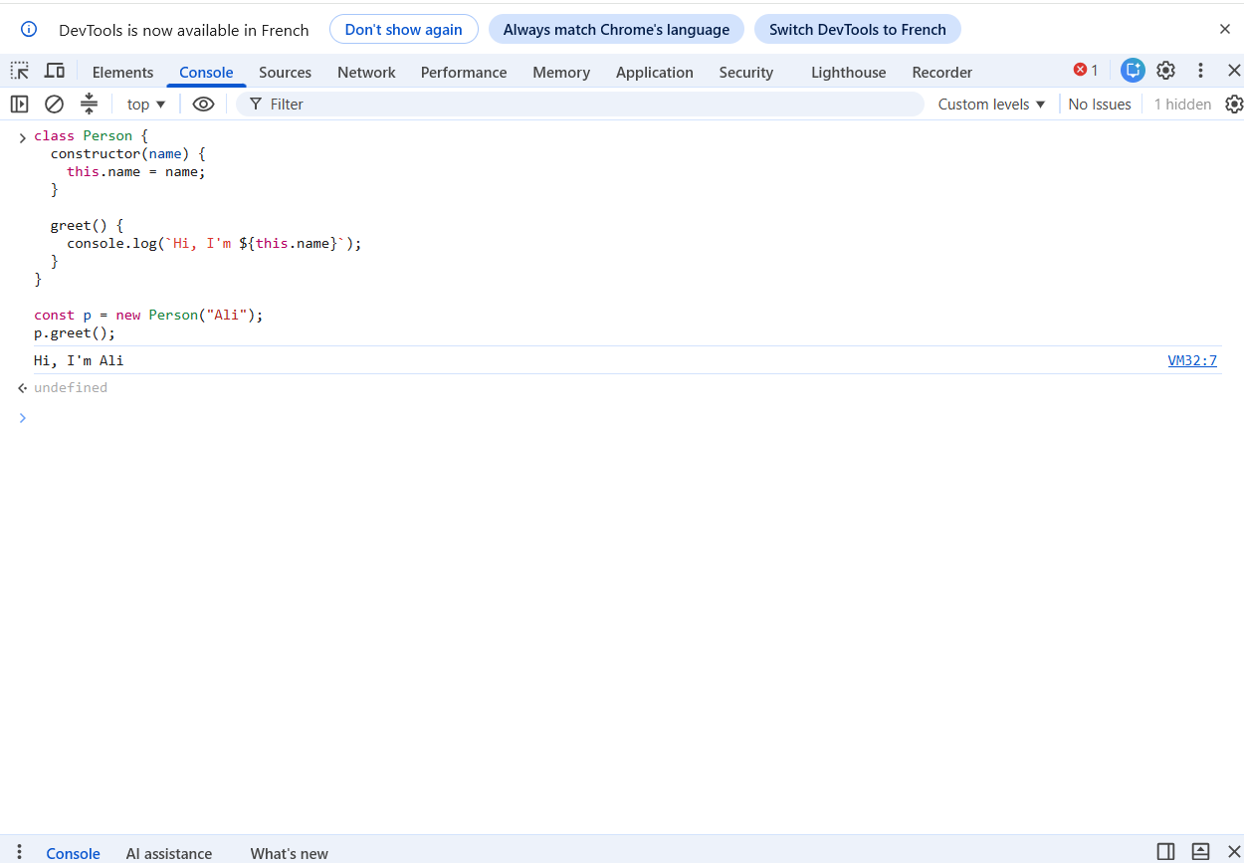

DOM basics (in browser)
Use the DOM API to read and modify HTML elements.
js
// Select element
const btn = document.getElementById("myBtn");

// Change text
btn.textContent = "Click me";

// Add event listener
btn.addEventListener("click", () => {
alert("Button clicked");
});
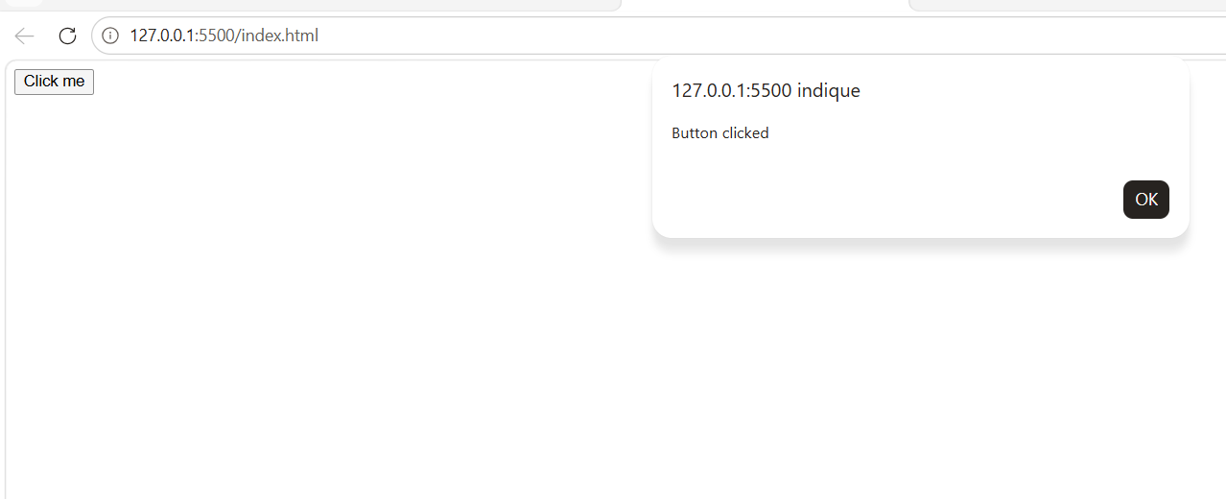

Modules (ES Modules) :
To test functionalities that require a web server, you can either install Live Server in VS Code (cf. figure) or install a Node.js HTTP server.

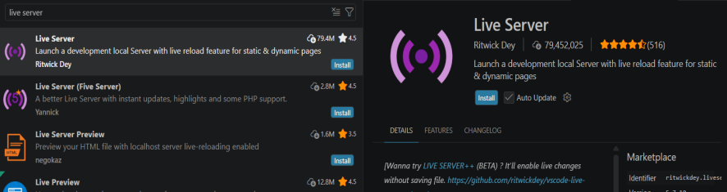
Right-click on the index.html file in the editor and select “Open with Live Server.”
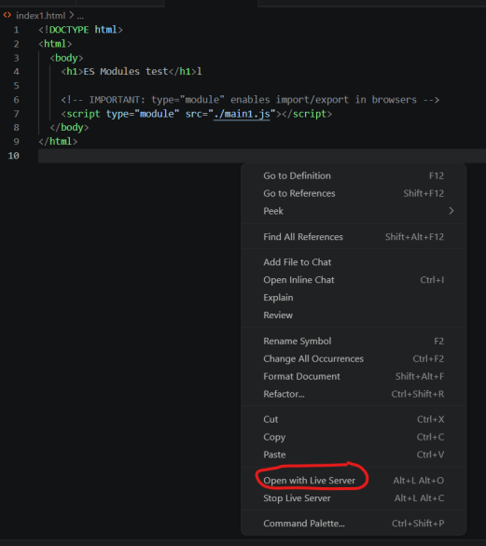

A web page will pop up in your configured browser. After that, press F12 to open the browser console.

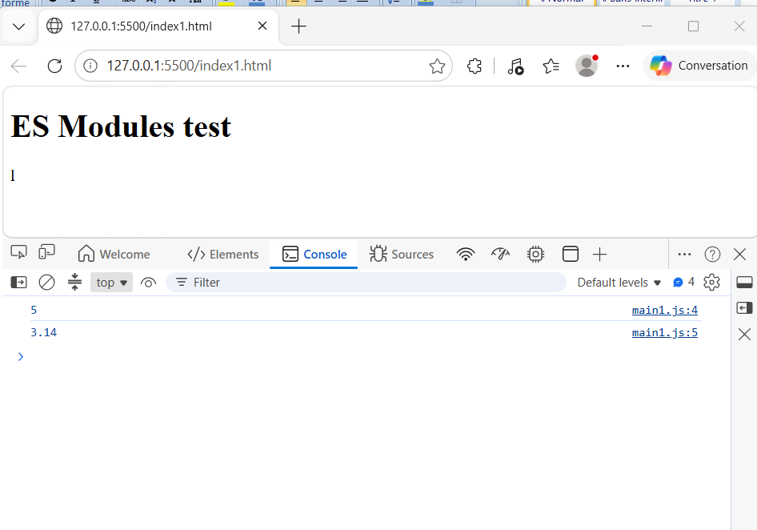

Modern JS uses import/export syntax for modules.
- Create math.js
js
// math.js
export function add(a, b) {
return a + b;
}
export const PI = 3.14;
- Create main.js

// main.js
import { add, PI } from "./math.js";

console.log(add(2, 3));
console.log(PI);
- Create index.html
<!DOCTYPE html>
<html>
<body>
<h1>ES Modules test</h1>

<!-- IMPORTANT: type="module" enables import/export in browsers -->
<script type="module" src="main.js"></script>
</body>
</html>

Async: callbacks, promises, async/await
JavaScript is single-threaded but uses an event loop; async code is handled with callbacks, promises, and async/await.
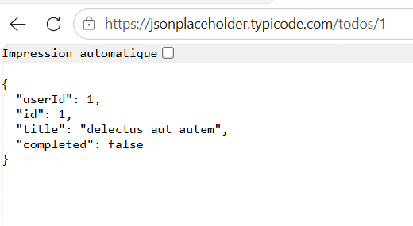
Method1:
<!DOCTYPE html>
<html>
<body>
<h1>Fetch test</h1>

<p id="title">Waiting for data...</p>

<script>
const titleEl = document.getElementById("title");

// Helper to wait ms milliseconds
function sleep(ms) {
return new Promise(resolve => setTimeout(resolve, ms));
}

// -------- Version 1: then / catch --------
function getData() {
// WRONG URL on purpose to test error
return fetch("https://jsonplaceholder.typicode.com/todos/1");
}

getData()
.then(res => {
// IMPORTANT: fetch resolves even for 404, so we must check manually
if (!res.ok) {
throw new Error("HTTP error " + res.status);
}
return res.json(); // convert response to JS object
})
.then(data => {
// wait 10 seconds before displaying
return sleep(10000).then(() => data);
})
.then(data => {
console.log("then/catch:", data);
titleEl.textContent = data.title;
})
.catch(err => {
console.error("Error:", err);
titleEl.textContent = "Error loading data";
});

</script>
</body>
</html>

Method 2 :
<!DOCTYPE html>
<html>
<body>
<h1>Fetch test</h1>

<p id="title">Waiting for data...</p>

<script>
const titleEl = document.getElementById("title");

// Helper to wait ms milliseconds
function sleep(ms) {
return new Promise(resolve => setTimeout(resolve, ms));
}

// -------- Version 2: async / await --------
async function loadData() {
try {
// WRONG URL on purpose to test error
const res = await fetch("https://jsonplaceholder.typicode.com/todos/1");
await sleep(10000);

// fetch does NOT throw on 404, so we must check manually
if (!res.ok) {
throw new Error("HTTP error " + res.status);
}

const data = await res.json();

// wait 10 seconds before displaying

console.log("async/await:", data);
titleEl.textContent = data.title;
} catch (err) {
console.error("Async error:", err);
titleEl.textContent = "Error loading data";
}
}

loadData();
</script>
</body>
</html>
Upon running the program , we get :

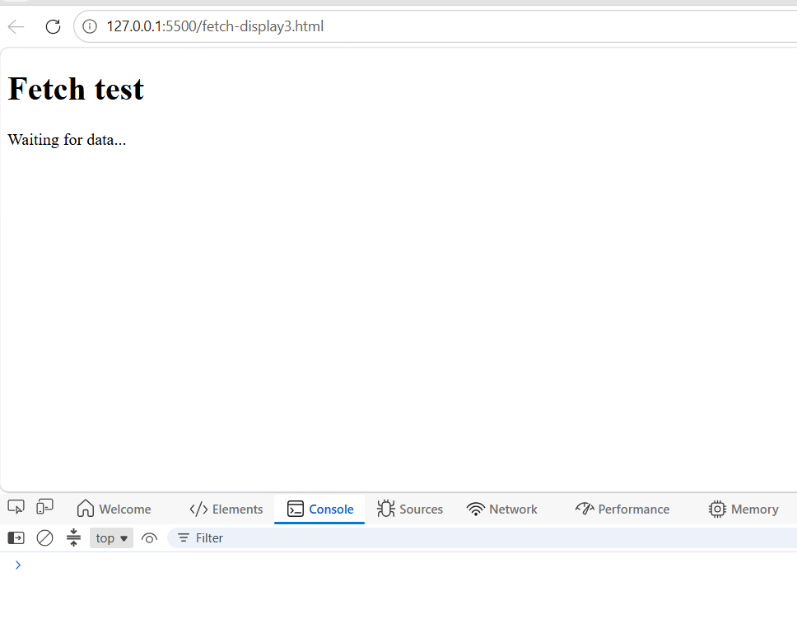
After 10 secondes we get the final response
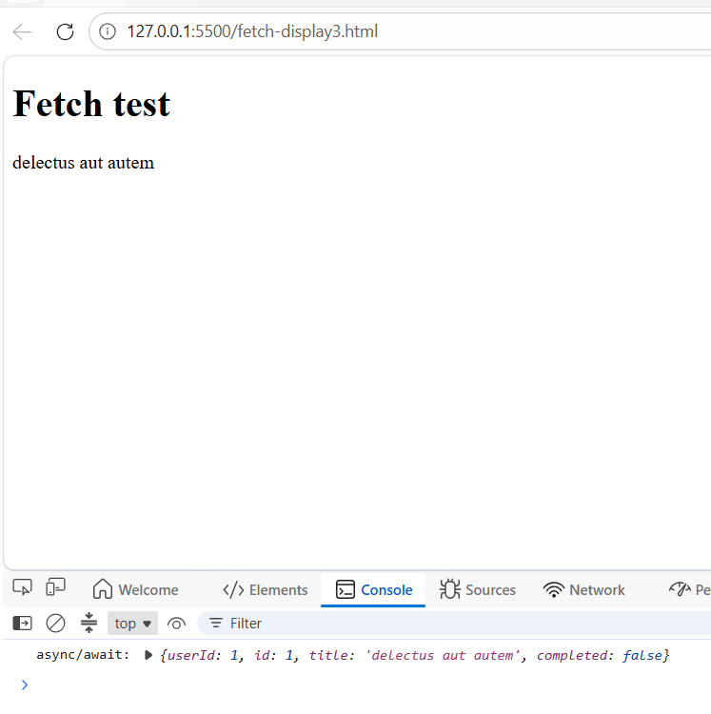

RESTful API and its usage :
A RESTful API (Representational State Transfer API) is a web interface that follows the REST architectural style to let different applications—typically a browser or mobile app on the frontend and a backend server—communicate with each other over HTTP by sending and receiving structured data, usually JSON. As shown in the diagram, the client (frontend) issues HTTP requests such as GET, POST, PUT, and DELETE to the REST API, which processes these requests, interacts with a database to query or modify data, and then returns HTTP responses containing both the requested data and a status code indicating success or failure; this pattern has become the standard way in web development for frontends to create, read, update, and delete data on back-end services or external platforms.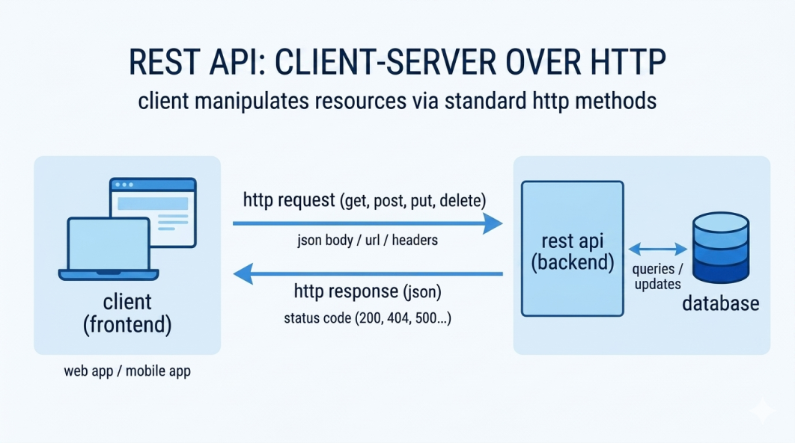

What “REST” means
- REST = Representational State Transfer, an architectural style defined by Roy Fielding for building scalable web systems.
- A REST API (or RESTful API) is an API that conforms to these REST principles when exposed over HTTP.
Key idea: the server exposes resources (users, orders, products, posts, etc.) as URLs, and clients manipulate representations of those resources (usually JSON objects) using standard HTTP methods.

Core principles / constraints :
Classic REST constraints that a “truly RESTful” API should follow:
- Client–server: frontend and backend are separated; the client only needs to know the API’s URLs, not internal implementation.
- Stateless: each request contains all the information needed (URL, headers, body); the server does not store session state between requests.
- Cacheable: responses can declare themselves cacheable to improve performance (e.g. Cache-Control header).
- Uniform interface: consistent way to access resources via URIs and HTTP methods (GET, POST, PUT, DELETE…) and consistent representations (JSON/XML).
- Layered system: clients don’t know whether they’re talking directly to the origin server or through proxies/gateways, which improves scalability and security.
- Code on demand (optional): server may return executable code (e.g. JavaScript) to extend client functionality, but this constraint is rarely required.
If a service breaks most of these (especially stateless, client–server, uniform interface), it is usually not considered RESTful.

How a RESTful API works in practice:
A REST API typically:
- Exposes resources via URLs (URIs) like /users, /users/123, /orders/42.
- Uses HTTP methods as verbs:
  - GET /users/123 → get user 123
  - POST /users → create a new user
  - PUT /users/123 or PATCH /users/123 → update user 123
  - DELETE /users/123 → delete user 123
- Returns representations of resources, usually JSON, sometimes XML or HTML.
- Uses standard HTTP status codes (200, 201, 400, 404, 500…) to indicate success or error.
Example (simplified):
- Frontend sends GET https://api.example.com/todos/1.
- REST API returns JSON:
//json
{
"id": 1,
"title": "Buy milk",
"completed": false
}
This JSON is a representation of the “todo” resource with id 1.

What RESTful APIs are used for in web development:
In modern web apps, RESTful APIs are used to:
- Connect frontend to backend: React/Angular/Vue frontends call a REST API to read and modify data (users, posts, products) instead of accessing the database directly.
- Integrate external services: websites talk to payment gateways (Stripe), authentication providers (Auth0), CRMs, social networks, etc., all via REST APIs.
- Provide mobile app backends: Android/iOS apps use REST APIs as their main channel to sync data with a server or cloud backend.
- Enable interoperability / microservices: different microservices or third-party systems communicate over REST so teams can build and deploy services independently.
Because REST relies on standard HTTP and simple formats like JSON, it’s easy to consume from browsers, mobile devices, and server-side code in many languages.

Why RESTful APIs are popular
REST became the default for web APIs because it offers:
- Simplicity: uses familiar web concepts: URLs, HTTP verbs, status codes, JSON.
- Scalability: stateless, cacheable design works well at large scale.
- Loose coupling: clients and servers can evolve independently as long as the contract (URLs + representations) stays consistent.
- Tooling support: almost every language/framework (Django, Express, Spring, Laravel, etc.) has built-in support for building or consuming REST APIs.
CSS cheat sheet
CSS (Cascading Style Sheets) is the language used to control the visual presentation of HTML or XML documents: colors, fonts, spacing, layout, responsive behavior, and more. It lets you separate content (HTML) from design, so you can style multiple pages consistently and adapt the layout to different devices and screen sizes.

What CSS is used for
CSS is mainly used to:
- Set colors, fonts, and text styles (e.g. headings blue, body text 16px).
- Control spacing: margins, padding, line-height.
- Define page layout: multi-column designs, grids, flex layouts, positioning.
- Make pages responsive so they look good on mobile, tablet, and desktop using media queries.
- Add visual polish: borders, backgrounds, hover effects, basic animations.
In short, HTML builds the structure of the page, and CSS turns that structure into a designed, usable interface.

Basic CSS syntax
The fundamental pattern of a CSS rule is:
css
selector {
property: value;
}
Selector: which HTML element(s) to style (e.g. p, .btn-primary, #main-header).
- Property: what aspect you’re changing (e.g. color, font-size, margin).
- Value: the setting for that property (e.g. blue, 18px, 10px).
Example:
css
p {
color: blue;
font-size: 16px;
}
This makes all <p> elements blue, with a font size of 16px.
You can combine multiple properties in one rule:
css
button.primary {
background-color: #007bff;
color: white;
padding: 8px 16px;
border-radius: 4px;
}

Common CSS properties
Some of the most frequently used properties include:
- Text & font
- color – text color
- font-family – font (e.g. Arial, sans-serif)
- font-size – size of text
- font-weight – boldness (e.g. bold, 700)
- text-align – left, center, right
- Box model & spacing
- margin – space outside the element
- padding – space inside the element
- border – line around the element (width, style, color)
- width, height – element size
- Background & decoration
- background-color – element background color
- background-image – image backgrounds
- border-radius – rounded corners
- box-shadow – drop shadows
- Layout
- display – block, inline, flex, grid
- position – static, relative, absolute, fixed
- flex / grid-* properties for modern layout systems
Conclusion:
CSS is the layer that turns bare HTML into usable, attractive, and responsive interfaces, controlling layout, colors, typography, and overall visual identity across devices. By mastering core syntax (selectors, properties, and values) and the most common properties, a developer gains the tools to build consistent, maintainable designs that significantly improve usability and user experience, making CSS an essential skill for any modern web project.

